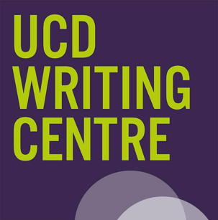
UCD Thesis Write-A-Thon

Brought to you by the ucd writing Centre and Graduate Studies

Application Form
General Information
This form is to be completed by the applicant and then submitted to writing.centre@ucd.ie. Please return this form in .doc or .docx format. Do not pdf, jpeg etc this form. Handwritten forms will not be accepted.
Closing Date | February 24, 2026 | Late applications will not be accepted
Receipt of your application will be acknowledged by email. If you have not received an e-mail acknowledgement by Friday 27th February please contact Dr Zeljka Doljanin at the above email address. Applicants will be notified of the outcome to their application on Monday 2nd March.
Dates, Times, and Venue | Day One: Friday March 27 (9am-5pm)  Day Two: Saturday March 28 (10am-4pm) | H2.38 Science Hub – O’Brien Centre of Science

Applicant Details
Title |  |  | Student number
Forename |  |  | Surname
Email address |  |  |  |  | School/Area
Please indicate if you are |  | Part Time |  |  |  | Full Time

Your Thesis
How many words of your thesis have you written to date?
When did you commence your degree? | Month: |  | Year:
When do you expect to submit your thesis? | Month: |  | Year:

Applicant Research Profile
In one sentence, why would you like to participate in this Thesis Write-A-Thon?

What do you hope to achieve during the UCD Thesis Write-A-Thon? You should be specific here. For example, you may choose to add 5,000 words to a section like a literature review or discussion; similarly, you may set yourself the goal to finish drafting a section of your work. These sessions will be better suited to generative writing rather than editing, proofreading, or research.

Applicant Statement and Signature (please tick)
I would like to participate in Thesis Write-A-Thon, which I acknowledge is an intensive and dedicated writing environment.
I agree to attend both days of the programme (timings listed on page 1 of this form).
Applicant signature: |  | Date:

